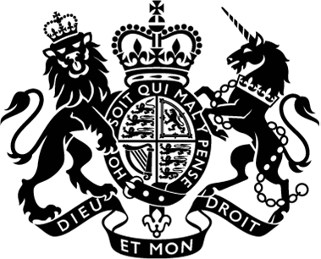

17th June 2021

Excellency,

I have the honour to invite you personally to the July Ministerial, which I am delighted to say will be hosted in-person in London from the 25th to 26th July. The sessions will commence at 09.00 on 25th July and close at 18.00 on 26th July.

The Ministerial is an important milestone on the road to COP26 in November and will bring together ministers from a balanced and representative range of countries. The Ministerial will build on earlier productive ministerial engagements at the Ministerial on Climate Action and the Climate and Development Ministerial in March, and the Petersberg Climate Dialogue in May.

Whilst the event is not part of the mandated schedule of the United Nations Framework Convention on Climate Change, it will focus on some of the key negotiations topics to be addressed at COP26. We propose the following topics will be covered during the July Ministerial, in line with the four goals of COP26:

1. Scaling up adaptation
2. Keeping 1.5c alive
3. Finalising the Paris Rulebook: Article 6
4. Mobilising finance
5. Loss & Damage

Further details on the programme and format of the Ministerial, including detailed logistical arrangements will be issued in due course.

Excellency, I look forward to welcoming you in-person to the UK on the 25th and 26th July. Together, we can make tangible progress across some of the most pressing issues we need to address at COP26.

Please accept, Excellency, the assurances of my highest consideration.



The Rt Hon Alok Sharma MP  
COP President Designate